The Durham School of the Arts
Piano Studio’s Program Handbook

Mostly Everything You Need to Know About the Piano Program for this Year
2019 - 2020

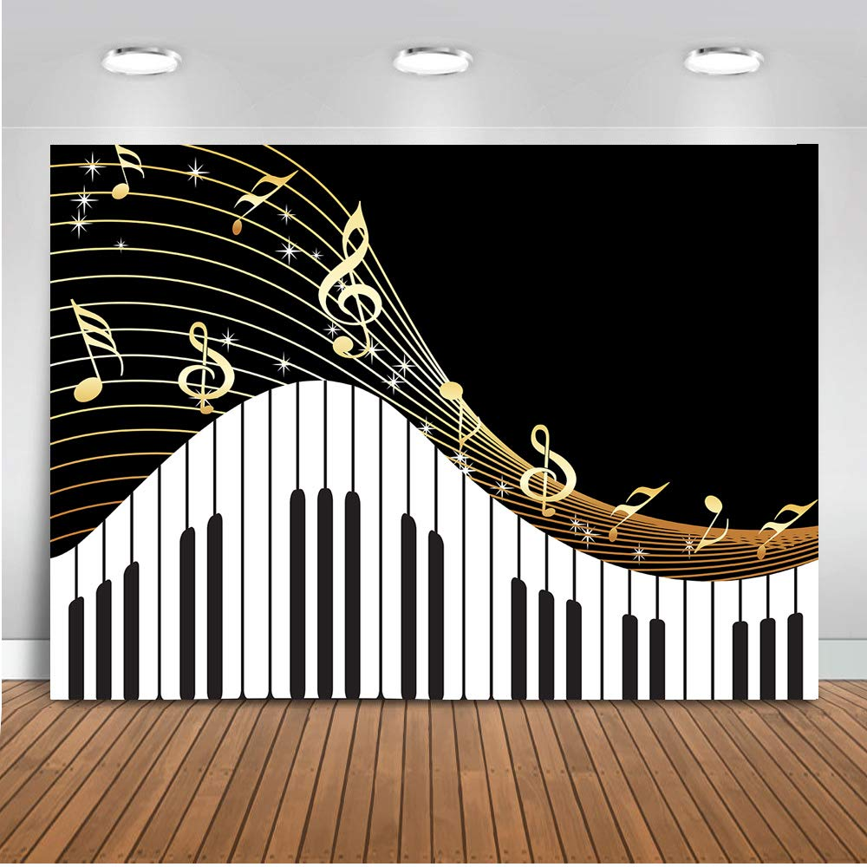

Arthur Davis
Piano Program Director
August 26th 2019

Greetings and Welcome to the Durham School of the Arts Piano Program!

It is an honor and privilege to continue or begin this musical collaboration with you! There is an exciting journey ahead of us full of excitement, enrichment and hard work.

The following is a handbook that contains all of the information that students, parents and guardians need to know in order to be successful contributors to the Durham School of the Arts Piano Program. Please read it VERY carefully. Included in this handbook is information on:

--COURSE DESCRIPTION
--GRADING POLICIES
--ATTENDANCE
--SAFE ZONE
--PERFORMANCE CALENDAR
--MEDIA RELEASE FORM
--HANDBOOK AGREEMENT FORM

Students, it is your responsibility to know and understand the information in this handbook, as it is crucial to your success as an individual in the Piano Program. Parents and guardians, please keep this document for your personal records as it outlines the expectations that I will hold your students to this year. Parents, guardians and students please go over this information together to assure that everyone mutually understands the content. After reading the handbook thoroughly, please sign the Handbook Agreement Form, Media Release Form, and Volunteer Form, found on the last page of the document. Students and parents must BOTH sign this form. If there are any questions about the handbook, please feel free to speak with me at any point.

You may contact me Monday-Friday using the contact information listed below. I look forward to a great year!

All the best,

Arthur Davis
Phone: 919.560.3926, ext. 23463
E-Mail: Arthur.Davis@dpsnc.net
Best Times to Reach: 8:00am – 8:30am and 3:45pm – 4:30pm

Many thanks to Mr. Grier, Mrs. Davis, and Mr. Gibson who’s Choral and Orchestra Department Handbooks which this handbook is modeled after

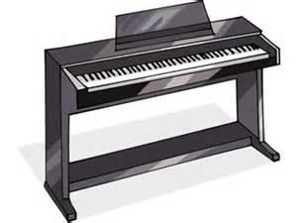

The most important rule in Piano Class is to be respectful of the new pianos that have been purchased by the school. The price of one Pi50 electric keyboards is $5000.00. We have 25 pianos for a net worth of $125,000.00.

The price of one special microphone headphone is $50.00. We have 25 headphones for a net worth of $1,250.00.

Do not place anything on your piano except for sheet music. Please use the floor under the keyboard for personal items (backpack, lunchbox, etc...)

Be very careful putting on and off your headphones. We had to replace seven headphones last year when they were dropped on the floor. They are very fragile.

Important Dates/Piano Recitals

Piano Recital -Tuesday, October 1st 2019 – 7:00pm

Piano Recital -Tuesday, November 12th 2019 – 7:00pm

Piano Recital -Wednesday, December 18th 2019 –7:00pm

Piano Recital -Thursday, January 9th 2020– 7: 00pm

Piano Recital -Tuesday, March 24th 2020 –7:00pm

Piano Recital -Tuesday, April 7th 2020 – 7:00pm

6th DSA PIANO FESTIVAL– SATURDAY, May 9th 2020

Piano Recital -Tuesday, May 26th 2020 – 7:00pm

Senior Recital - Saturday, June 6th 2020 – 2:00pm

Graduation - Thursday, June 13th 2020 – 5:00pm
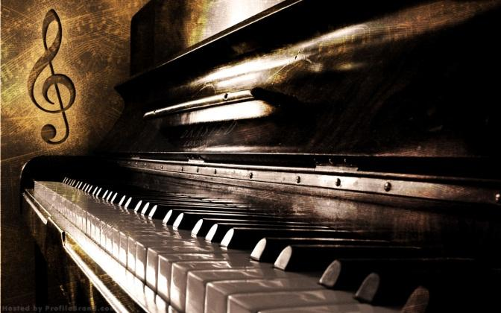

Daily Schedule

8:30-9:10 Available for extra help and conference by
appointment
9:15 –10:05 1st Period - Piano
10:11-11:01 2nd Period - Piano
11:07-11:57 3rd Period – Planning
11:57 – 12:28 Lunch
12:34 – 1:24 4th Period - Piano

1:31-2:21 5th Period - Piano
2:28-3:18 6th Period - Piano
3:25-4:15 7th Period - Piano
4:15-4:45 Available for extra help and conference by
appointment

Durham School of the Arts
Piano Studios Program Department
2019-2020
Mr. Arthur J. Davis

Course Descriptions:
It is an honor and a privilege to be a member of the Piano Program at the Durham School of the Arts. Students will be expected to work at a high level and to treat each other with respect. As a member of the Durham School of the Arts Piano Program, students will develop a deeper understanding of their instrument and proper playing technique. Each class will learn and perform at the appropriate level. Students will also be expected to think critically about various instrumental music listened to in class, as well as the historical and cultural implications of instrumental music.

Piano Lab 1
This course is designed for 9th grade students who have had prior successful musical experience in piano in middle school. The class focuses attention on piano literature, technique and music theory. Focus is placed on more advanced theory: key signatures, circle of fifths, triads and seventh chords and inversions, and ear training. Focus is placed on careful, clean pedaling, developing fluency, articulation, sight-reading, balance between melody and harmony and accurate interpretation of expression marks. Students play scales of three octaves in sixteenth notes at mm 90, and four octave arpeggios. Literature by composers such as Kabalevsky, Bartok, Kuhlau, Clementi and others is studied and performed. Artistic interpretation is stressed. Sight-reading level two materials and forty-five minutes daily of outside practice is expected.

Piano Lab 2
Students work on various pieces by Beethoven, Mozart, Schumann, Scarlatti, Chopin and other masters. At this level all instruction and repertoire are individualized with the teacher helping them select their pieces. They are expected to perform at a public school recital at least once a year. All performances are memorized. Scales and arpeggios are four octaves each. Sight-reading level two materials and forty-five minutes daily of outside practice is expected.

Piano Lab 3
Students continue to develop their knowledge of piano literature by learning various sonatas, Chopin preludes, waltzes and mazurkas, works by Beethoven, Mozart, Schumann, Scarlatti and other masters. At this level all instruction and repertoire are individualized, and students have a hand in choosing their pieces. They are expected to perform at a public school recital at least once each semester. All performances are memorized. Scales and arpeggios are four octaves each. Sight-reading level three materials and one hour daily of outside practice is expected.

Piano Lab 4 - Honors
This course is rigorous and requires advanced technical and interpretive skills. Students must play pieces in key signatures containing numerous flats and sharps, complex rhythms, unusual meters, and subtle dynamics. Repertoire represents different styles, cultures and musical periods. They must also be able to play major and minor scales at 100-140 mm and all major, minor, diminished 7th, dominant 7th and augmented arpeggios. They are expected to perform a minimum of two times a semester, and prepare a paper on one or more composers. Students at honors levels three and four may also accompany other instrumentalists or singers, choral ensembles, play in chamber music ensembles, playing in the pit orchestra for one of the yearly musicals or play in one of the jazz bands. Sight-reading level four materials and one and a half hours daily of outside practice is expected.

Piano Lab 5 - Honors
This course is rigorous and requires advanced technical and interpretive skills. Students continue to play pieces in key signatures containing numerous flats and sharps, complex rhythms, unusual meters, and subtle dynamics. Repertoire represents different styles, cultures and musical periods. Students learn to play in a number of styles including blues, rock, Broadway, Gospel, rag-time and jazz. The skills that are acquired are playing by ear, “comping”, writing dictation, reading a chord chart, reading a lead sheet, sight-reading popular sheet music and improvising in various styles. Students learn 7th, 9th 11th and 13th chords in all keys, chord inversions, blues, jazz and modal scales. Students at honors level four may also accompany other instrumentalists or singers, choral ensembles, play in chamber music ensembles, play in the pit orchestra for one of the yearly musicals or play in one of the jazz bands. These students are also expected to perform a minimum of two times a semester, and prepare a paper on one or more composers. Sight-reading level four materials and one and a half hours daily of outside practice is expected.

Piano Lab 6 - Honors
This course is rigorous, requires advanced technical and interpretive skills and is designed for individual musicians who are very self-directed and can complete assignments on their own. Students at this advanced level learn a complete recital repertoire involving pieces of great length and difficulty such as Liszt etudes, Barber and Chopin sonatas and full concertos. Most students at this level enter (and often win) local, state and national competitions. Besides performing a recital, these students perform often at DSA (minimum of twice a semester) and also for outside concert venues. Students at this level may also accompany other instrumentalists or singers, choral ensembles, play in chamber music ensembles, playing in the pit orchestra for one of the yearly musicals or play in one of the jazz bands. Sight-reading level five materials and two hours daily of outside practice is expected.

Required Materials
For 1st year and 2nd year pianist
The Older Beginner Piano Course By James Bastien – Level 1 and Level 2

Grading Policy:

Execution of Performance Practice (35% of Final Grade)
Students will earn 20 points for each day that they are present in class and practicing effectively. Therefore, students will earn a total of 100 points throughout the week. On a daily basis, students will be assessed on their ability to successfully convey, but not limited to, the following:
- Proper playing posture
- Proper hand position
- Listening Skills
- Attentiveness to the Music Instructor
- Adherence to Piano Room Rules (no gum, no food, no talking out of turn, no playing out of turn, etc.)
- Practice preparation for piano recitals
- Preparing a song to play for the class (every Friday)

Concert Performance (25%)
A DSA Piano Recital is like a test in math or science class. Throughout a given grading period, students will learn and practice material and concepts in order to display their knowledge, techniques and skills in a final assessment. In each piano class, the “final assessment” will be the concert (please see CALENDAR in Handbook for dates). This being said, each concert is extremely important. To receive full Concert Performance Points on a given date, the student must be on time, dressed appropriately (see Uniform section below), and contribute fully to the musical experience of the performance. If a student is absent from a
concert they will automatically lose all Concert Performance points for that grading period (please see Concert Attendance Policy below).

Written Work (20% of Final Grade)
Every grading period there will be a variety of written work assigned. Such examples might include, but are not limited to, turning in the Handbook Agreement Form, music theory worksheets, listening log journals, written or spoken student evaluations, take-home music analysis or composition.

Skills and Mastery (20% of Final Grade)
Each student in DSA piano class will be expected to master a variety of musicianship concepts throughout the year (please see Topics/Concepts section below). The listed concepts are necessary components in forging a holistic piano experience. There is not the expectation that any one student must be “practically perfect in every way,” however, we do expect each student to make strides in his or her skills throughout the grading period. Throughout each grading period, different forms of group and individual assessment will be given and scored.

Topics/Concepts
Care of Instrument
Proper Posture
Proper Hand and Playing Position
Fluency in Reading Pitches
Fluency in Reading Rhythm
Phrasing
Learning How to Practice
Putting it all Together

Grading Scale
The DSA Piano Program Department adheres to the grading system designated by The Durham Public Schools, which is as follows:
A_____90-100
B_____80-89
C_____70-79
D_____60-69
F_____59 and below

DSA Piano Program Classroom Policies:
Student Rehearsal Conduct Expectations (students lose points for these infractions due to the fact that they prevent them from rehearing effectively)
- Not being in their seat when the bell rings, or during class instruction
- Lack of participation and/or giving in to distractions:
- Poor posture: This prevents proper and healthy playing and is also disrespectful to the community.
- Doing homework from another class.
- Talking/texting/surfing the web/glancing upon a cell phone, I-(fill in the blank), etc.
- Cosmetology
- Excessive Socializing or Talking
- Students should arrive in class ready to work and MAKE MUSIC, not talk.
- Piano class should be enjoyable, but it is also a learning atmosphere.
- Nails should be short enough for you to be able to easily feel the key with the entire, fleshy pad of your finger. You do not want to have to make any hand, wrist, or arm position changes to try and accommodate for long finger nails.
- Each student must take ownership of their personal choices; actions and reactions.
- Disruptive Behavior
  - Any behavior that is counterproductive to the goals of the Piano Program
  - Leaving the seat before class is dismissed.
  - Teasing/harassment towards others in the community.
- Gum, Food, Candy, Pop and Juice
  - Eating and drinking is a real distraction and should not be taking place during class.
  - The Piano room should not fall victim to wrappers, bags, bottles or other litter.
  - Water bottles are acceptable.
- Not Being Prepared
  - Lack of pencil, method book or music, etc.

Daily Attendance
IMPORTANT: Students must be present for at least 50% of a school day on the date of concerts to perform that evening, as stated in the DSA Student Handbook.

Tardy Policy
A student who is tardy 3 or more times in class will be assigned to After School Detention, per DSA Student Handbook policy. New for the 2012-2013 School Year: Students who accumulate 3 tardies in a class will be assigned 1 unexcused absence. These absences DO count towards exam exemption.

Durham School of the Arts Handbook
All policies, rules, guidelines and expectations outlined in the DSA Student Handbook will be strictly adhered to in the DSA Piano Program Department.

DSA Piano Recital Information:
Concert Attendance Policy
- Missing a Piano Recital
  - If the student is present at the piano recital, appropriately dressed, and successfully performs the concert, then they shall receive full credit for the Concert Performance Points. Should the student have an excused absence (Please see ‘Excused Absences from a Concert’ below) from the Piano Recital, then he or she will have the opportunity to make up the points missed through an assignment due one week after the concert date. Should the student have an unexcused absence from the Piano Recital, he or she will receive 0% credit for the Concert Performance Points sector of their class grade and will not be allowed to make-up the points missed.

- Excused Absences from a Piano Recital
  - Legitimate illness (must not be in school the entire day of the concert). A parent or guardian must call or e-mail the director to discuss the situation in advance.
  - Circumstances beyond one's control, such as a death in the family.
  - Planned absence of which the director has been notified of at least 2 weeks in advance.

  - Unacceptable and Unexcused Reasons for Absences from a Piano Recital
  - “I couldn't find a ride.” Make arrangements well in advance with another parent or student or speak with Mr. Davis who will help you find a ride.
  - “I didn’t feel good.” If you are in school the day of the concert, you are expected to be at the concert that evening.
  - “I had family obligations.” Examples: A sibling’s basketball game, or Grandma’s birthday celebration. Please make every attempt within your family to honor these concert dates since they are provided in advance. If you are not present, you lose points.
  - “I forgot.” Daily reminders will be given in class, in addition to references in this handbook.
  - “Something has suddenly come up.” You have the full schedule on August 26. Mark it on your family’s calendar today.

**Absences from a performance due to an athletic event or other DSA activity are NOT excused absences. Students must communicate with all DSA coaches and staff at least 3 weeks in advance if a conflict arises with an athletic event or other DSA school event. It will be to the teacher’s discretion as to how the student’s grade will be affected.**

Concert Etiquette
We spend many hours to create a performance that is professional in sound, and in execution. We welcome you to support the success of your students by matching their professionalism as performers through your conduct as an audience member. Also, please be courteous of our performers by minding younger siblings.

Formal Attire
Students should look professional. “Dressed to impress.”

Safe Zone
The Piano Program is one that welcomes and accepts all students. Every member of the Durham School of the Arts student body, regardless of race, color, ethnicity, religion, gender, sexual orientation, gender identity and disability is assured to have a safe spot in the Piano Program.

There is zero tolerance for intolerance.

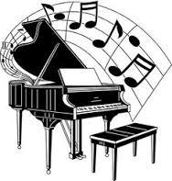

Contact Information:
Mr. Arthur Davis
Phone: 919.560.3926 ext. 23463
E-Mail: Arthur.Davis@dpsnc.net
Best Times to Reach: 8:00am – 8:30am and 4:15pm – 4:45pn

2019-2020 DSA Piano Studios Program
Handbook Agreement Form

Return this last page signed by Friday, September 6 2019

Please Print the Name of Student for which this form applies:

I have read and understand the information, rules and regulations within the 2019-2020 Durham School of the Arts Piano Studios Program.
I have marked all dates in our family's calendar, have discussed the handbook with my child, and will do my best to support the success of my child in DSA Piano Program.

Parent/Guardian Signature___________________________________________Date_________

__________________________________________________________________________________________
Family/Parent Email (Please Print As Neatly as Possible)

I have read and understand the information, rules and regulations within the 2019-2020 Durham School of the Arts Piano Program Handbook.
I have marked all dates in my planner, have discussed the handbook with my parent/guardian and will do my best to have a successful year in Piano Program.

Student Signature____________________________________________________Date____________

DSA PIANO CLASS
Piano Class Period_____________________
2019 – 2020
Parent/Student Information Sheet

(Please Print As Neatly as Possible)

Student Name______________________________________________________________ Grade___________________

Parent Name__________________________________________________________________________________________

Address_______________________________________________________________________________________________

Day Phone___________________________________ Evening Phone__________________________________

Cell Phone____________________________________

Parent’s Email________________________________________________________________________________________

Parent’s Email________________________________________________________________________________________

Student’s Email_______________________________________________________________________________________

Please check one of the following.
___________ 1. Yes, we have a piano/keyboard at home.
___________2. No, we do not have a piano/keyboard at home.

DSA Piano Studios Program
Media Release Form 2019-2020
Throughout the year, the DSA Piano Program uses photography and video in the classroom and at performances. First names may rarely be used in these publications; however, last names will remain confidential. Videos, photos and first names may appear on, but are not limited to, the following:

- The DSA website
- The DPS website
- The DSA Piano Program website
- Promotional videos for potential new students to DSA

These projects are designed to enhance learning on a daily basis, in addition to being used as a medium to publicize the many accomplishments of the DSA Piano Program to the surrounding community.

We would like to include all DSA Piano students in these endeavors. However, we understand that some students and their families may not be comfortable with this situation, and would prefer not to be included in this type of publication.

Please complete the media release below, by granting or denying permission for the DSA String Program to include your student and their first name in video, photo or internet projects.

YES, I, _________________________________________________________________(Parent/guardian printed name) give the DSA Piano Program, permission to photograph and video ______________________________________________(Student printed name) and potentially use their first name in DSA Piano publications during the 2019-2020 school year.

X____________________________________________________________________________ (Parent Signature) Date____________________

YES. I, ____________________________________________________________________ (Student printed name) give the DSA Piano Program, permission to photograph and video myself, and potentially use my first name in DSA Piano publications during the 2019-2020 school year.

X___________________________________________________________________________ (Student Signature) Date ___________________

NO, I, ________________________________________________________ (Parent/guardian printed name) do NOT give the DSA Piano Program, permission to photograph and video_______________________________________________________ (Student printed name), and potentially use their first name in DSA Piano publications during the 2019-2020 school year.

X_______________________________________________________________________ (Parent Signature) Date_________________________

NO, I, ___________________________________________________________, (Student printed name) do NOT give the DSA Piano Program, permission to photograph and video myself, and potentially use my first name in DSA Piano publications during the 2019-2020 school year.

X________________________________________________ (Student Signature) Date_______________

